# MOBILE APP DEVELOPMENET LAB

# WEEK 3:

# Program:

Create a screen that has input boxes for User Name, Password, Address, Gender (radio buttons for male and female), Age (numeric), State (Spinner) and a Submit button. On clicking the submit button, show all the data (use any layout)

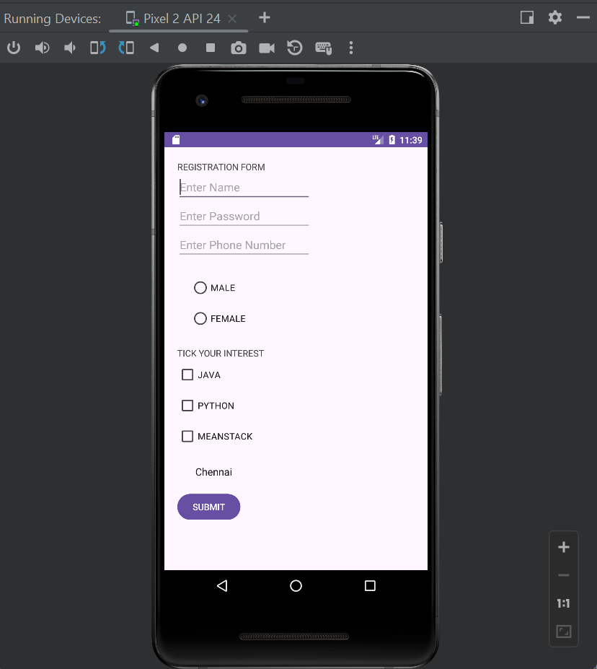 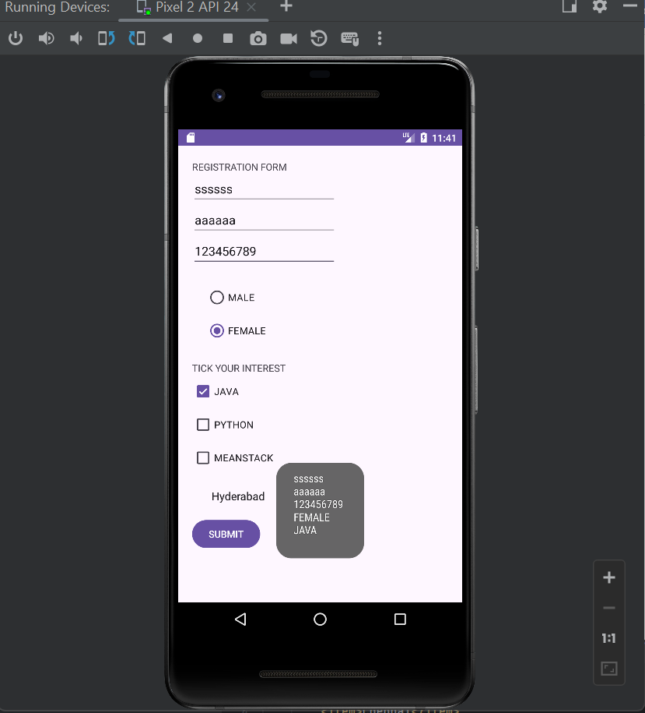

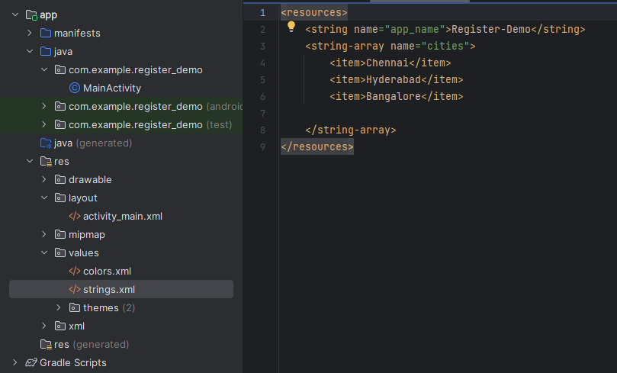**Strings.xml**

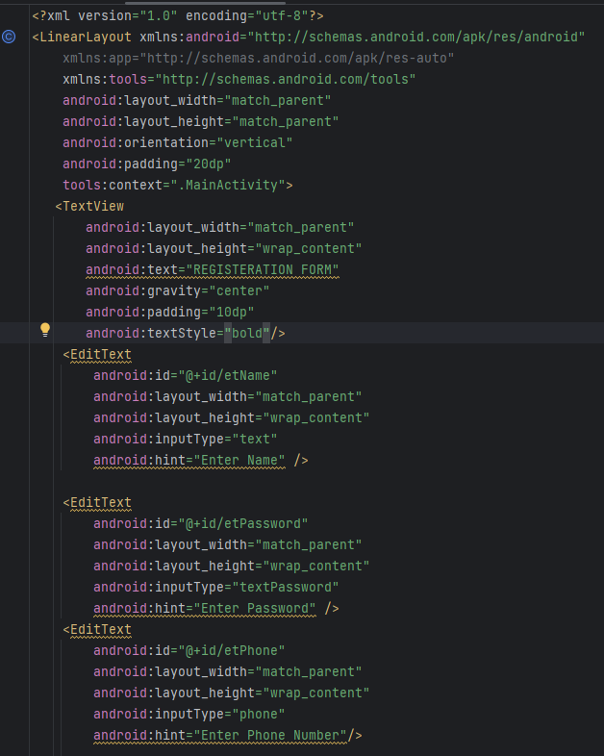**activity_main.xml**

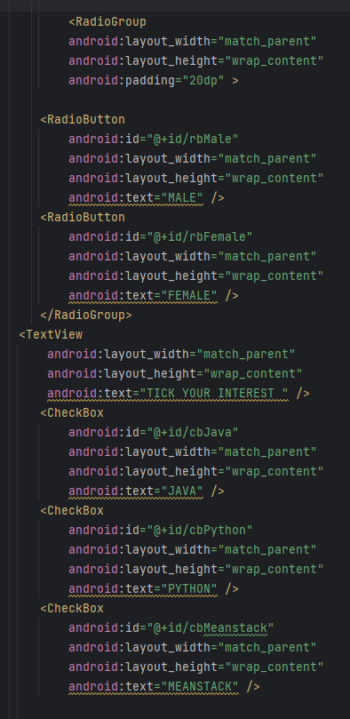

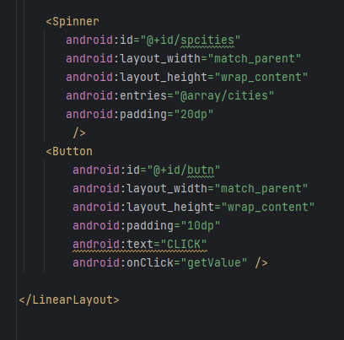

**MainActivity.java**

